**BMS INSTITUTE OF TECHNOLOGY & MANAGEMENT**

YELAHANKA, BENGALURU – 560064



**Department of Computer Science and Engineering**

**PROJECT BASED LEARNING (PBL)**

**Project Report**

***“*FAKE PRODUCT IDENTIFICATION USING BLOCKCHAIN”**

Web Technology and its Application – 18CS63

VI Semester, 6A CSE

***Submitted By***

**Bhavana N S** USN: 1BY20CS038

**Brundaja D N** USN: 1BY20CS041

**B C Narendra**  USN: 1BY21CS402

**Chethan Kumar N** USN: 1BY21CS405

Under the Guidance of

|  |  |
| --- | --- |
| Dr. Nagabhushan S V  Associate Professor |  |

2022-2023

**INSTITUTE VISION**

To emerge as one of the finest technical institutions of higher learning, to develop engineering professionals who are technically competent, ethical and environment friendly for betterment of the society.

**INSTITUTE MISSION**

Accomplish stimulating learning environment through high quality academic instruction, innovation and industry-institute interface.

**DEPARTMENT VISION**

To develop technical professionals acquainted with recent trends and technologies of computer science to serve as valuable resource for the nation/society.

**DEPARTMENT MISSION**

Facilitating and exposing the students to various learning opportunities through dedicated academic teaching, guidance and monitoring.

**PROGRAM EDUCATIONAL OBJECTIVES**

1. Lead a successful career by designing, analyzing and solving various problems in the field of Computer Science & Engineering.
2. Pursue higher studies for enduring edification.
3. Exhibit professional and team building attitude along with effective communication.
4. Identify and provide solutions for sustainable environmental development.

**Program Specific Outcomes (PSOs):**

1. Analyze the problem and identify computing requirements appropriate to its solution.
2. Apply design and development principles in the construction of software systems of varying complexity.

|  |  |
| --- | --- |
| **Web Technology and its Applications 18CS63 - Course Outcomes (Cos)** | |
| CO | * Illustrate the Semantic Structure of HTML and CSS and Design Client-Side programs using JavaScript and Server-Side programs using PHP. * Examine JavaScript frameworks such as jQuery and Backbone |

**Project to Program Outcomes (PO) Mapping**

**Project Name: FAKE PRODUCT IDENTIFICATION USING BLOCKCHAIN**

|  |  |  |  |  |  |  |  |  |  |  |  |  |  |  |
| --- | --- | --- | --- | --- | --- | --- | --- | --- | --- | --- | --- | --- | --- | --- |
| **COURSE** | **PO1** | **PO2** | **PO3** | **PO4** | **PO5** | **PO6** | **PO7** | **PO8** | | **PO9** | **PO10** | | **PO11** | **PO12** |
| **Web technology and its application** |  |  |  |  | √ √ | |  | √ | √ | | | √ |  | √ |

|  |  |
| --- | --- |
| **Program outcomes (POs):** | |
| **PO1** | **Engineering knowledge:** Apply the knowledge of Mathematics, Science, Engineering fundamentals and an engineering specialization to the solution of complex engineering problems |
| **PO2** | **Problem analysis:** Identify, formulate, review research literature, and analyze complex Engineering problems reaching substantiated conclusions using first principles of mathematics, Natural sciences and engineering sciences |
| **PO3** | **Design/development of solutions:** Design solutions for complex engineering problems and design system components or processes that meet the specified needs with appropriate consideration for the public health and safety, and the cultural, societal, and environmental considerations. |
| **PO4** | **Conduct investigations of complex problems**: Use research-based knowledge and research methods including design of experiments, analysis and interpretation of data, and synthesis of the Information to provide valid conclusions |
| **PO5** | **Modern tool usage**: Create, select, and apply appropriate techniques, resources, and modern Engineering and IT tools including prediction and modelling to complex engineering activities with an understanding of the limitations. |
| **PO6** | **The engineer and society:** Apply reasoning informed by the contextual knowledge to assess societal, health, safety, legal and cultural issues and the consequent responsibilities relevant to the professional engineering practice. |
| **PO7** | **Environment and sustainability:** Understand the impact of the professional engineering solutions in societal and environmental contexts, and demonstrate the knowledge of, and need for Sustainable development |
| **PO8** | **Ethics:** Apply ethical principles and commit to professional ethics and responsibilities and norms of the engineering practice. |
| **PO9** | **Individual and team work:** Function effectively as an individual, and as a member or leader in diverse teams, and in multidisciplinary settings |
| **PO10** | **Communication:** Communicate effectively on complex engineering activities with the engineering Community and with society at large, such as, being able to comprehend and write effective reports And design documentation, make effective presentations, and give and receive clear instructions. |
| **PO11** | **Project management and finance:** Demonstrate knowledge and understanding of the Engineering and management principles and apply these to one’s own work, as a member and Leader in a team, to manage projects and in multidisciplinary environments. |
| **PO12** | **Life-long learning:** Recognize the need for, and have the preparation and ability to engage in independent and life-long learning in the broadest context of technological change. |

**Project to Program Specific Outcomes (PSO) Mapping**

|  |  |
| --- | --- |
| **Program Specific Outcomes (PSOs):** | |
| **PSO1** | Analyze the problem and identify computing requirements appropriate to its solution. |
| **PSO2** | Apply design and development principles in the construction of software systems of varying complexity. |

**Project Name: Fake product identification using blockchain**

|  |  |  |
| --- | --- | --- |
| **COURSE** | **PSO1** | **PSO2** |
| **Web technology and its application** | **√** | **√** |

**Abstract:**

Blockchain innovations have acquired interest in the course of the most recent years. One of the most talked about issues is currency exchange, but its application is not limited only to Digital currency. so it has the potential to influence different business sectors. Blockchain technology has brought greater transparency and ease in large transactions. We can detect counterfeit goods using blockchain technology. The question that arises when buying any item in today's world is whether it is fake or not. And the lack of these things has been shown a huge impact on economic progress. Therefore, in order to curb all counterfeit goods, it is important to bring transparency about the goods to the notice of the consumers.

The growing presence of counterfeit and unsafe products in the world is a cause for concern and blockchain technology has taken the next step towards its complete annihilation. Not only the use of technology will reduce the production of counterfeit goods, but everyone needs to be aware of this. By producing and packaging the right items each of those items needs to be given a digital code with its own identity. The software implementation process in which the product code is scanned using this application and then verify if the given product is counterfeit or not.

**Introduction:**

The global development of a product or technology always comes with risk factors such as counterfeiting and duplication, which can affect the company's name, company revenue, and customer health. There are so many products that exist in the supply chain. To ensure that the product is real or fake. Because of counterfeit or fake products manufacturers facing the biggest problem and huge losses. To find the genuineness of the product we can use blockchain technology. Blockchain is an arrangement of recording information that makes it troublesome or hard to change, hack, or cheat the framework. A blockchain is essentially a computerized record of transactions that is duplicated and distributed across the entire network of PC systems on the blockchain. Each block in the chain contains multiple transactions, and every time a new transaction occurs on the blockchain, a record of that transaction is added to every participant’s record. The decentralized database managed by the number of participants is known as Distributed Ledger Technology (DLT).

Blockchain is a type of DLT in which transactions are recorded with an immutable cryptographic signature called a hash. Blockchain technology helps to solve the problem of counterfeiting a product. Blockchain technology is more secure. Once the product is stored on the network hash code is generated of that product and it is possible to maintain all transaction records of the product and its current owner as a chain will be created for that product transactions. All the transaction records will be stored in the form of blocks in the blockchain. In the proposed system we are assigning a generated QR code to a particular product and the end customer can scan

**Motivation:**

* In recent years, the spread of counterfeit goods has become global. There are many fake products in the current supply chain.
* According to the report, fake product incidents have risen in the last few years. It is necessary to have a system for customers or users to check the all details of the product so that users can decide that the product is real or fake.
* In India currently, there is no such system to detect counterfeit products. So, the solution involves a simple QR code-based identification that can help the end-user or customers to scan and identify the genuineness of the product by using a smartphone.

**Existing System:**

* Data trading has become a popular research topic in recent years. This forum uses a recurring auction method to achieve greater efficiency in order to improve self-interest behavior among users.
* Login methods are used to achieve WSN accountability. This is a response to invaders of energy theft in the space of smart clouds.
* Shingling and MinHashing have long been used to obtain a copy of the text to obtain the same text.
* This method is used for word-based similarities.

**Limitations of Existing System:**

* Unscrupulous buyers may illegally sell data sets purchased from others.
* The previous method is used to monitor the seller's side but it is not appropriate to identify the broker.
* Heavy monitoring system cannot survive because it leads to poor user experience.

**Proposed System:**

As counterfeiting products are increasing widely in the world, we need to develop a full-fledged application system that will help us to identify these counterfeiting products. In this paper, the proposed system is that it will store the supply chain of the product and keep the history of ownership of the products. So that when the customers buy this product they will see the complete information about the product and decide whether the product is authenticated or not. We will use QR codes to verify the products and add information about the product. And for storing the data of the product we need to use a system that does not allow anyone to change the existing data, this can be achieved by blockchain technology. **So in this proposed system, we are using blockchain, and QR codes to detect fake products.**

**System Requirement Specifications**

**functional Requirements:**

A functional requirement defines a function of a system or its component. Where a function is described as a specification of behavior between inputs and outputs. • System must be automatically connecting to Wallet.

• System should be able to scan the QR code.

• System Should be able to generate the QR code.

• System Should show error message if the uploaded image is not QR code.

• Auto update of scanned location of the QR code.

• Storing all these details in blockchain nodes.

**NON-Functional Requirements:**

Software requirement can be non-functional and also be a performance requirement. Nonfunctional requirements are the characteristics or attributes of the system that can judge its operation.

The nonfunctional requirements are divided into usability, reliability, performance, Supportability and safety.

* + **Usability** ->The system must be easy to learn for manufacturers , retailers , distributors and mainly for consumers.
  + **Reliability**-> The reliability of the device essentially depends on the software tools such as metamask, remix IDE, Ganache used for the system development.
  + **Performance->** The system shall allow the system administrator to add additional features. The system needs to be cost-effective to maintain.
  + **Safety**->In case of malfunction, scanning from the manufacturers side should be stopped , and also it must be notified to others that it is not working.

**PROPOSED METHODOLOGY:**

Figure : Block Diagram of Fake Product Identification

Business runs on information. The faster it’s received and the more accurate it is, the better. Blockchain is ideal for delivering that information because it provides immediate, shared and completely transparent information stored on an immutable ledger that can be accessed only by permissioned network members. A blockchain network can track orders, payments, accounts, production and much more. And because members share a single view of the truth, you can see all details of a transaction end to end, giving you greater confidence, as well as new efficiencies and opportunities. After the product is recorded in a network it will create a smart contract and a unique QR code of the product in which the details of the product is mentioned in an encrypted text form. The manufacturer will ship the product to the distributor and status is set as shipped; it will not change the ownership of the product until a request from both parties is approved to buy and sell the product. Once the consumers receive the product the Buyers can scan QR code allocated to the item and verify the authenticity.

**System architecture/design:**

**implementation:**

**HARDWARE REQIUREMENTS:**

Operating Systems: Windows 7 or above.

Hard disk : 20GB

RAM :4GB and above.

Processor: i3 and Above

**SOFTWARE REQUIREMENTS:**

Tools : Xampp

Language : Solidity

Front end : HTML, CSS, JavaScript

IDE’s : Visual Studio

MetaMask wallet Ganache (personal blockchain).

Index.html Manufacturer.html

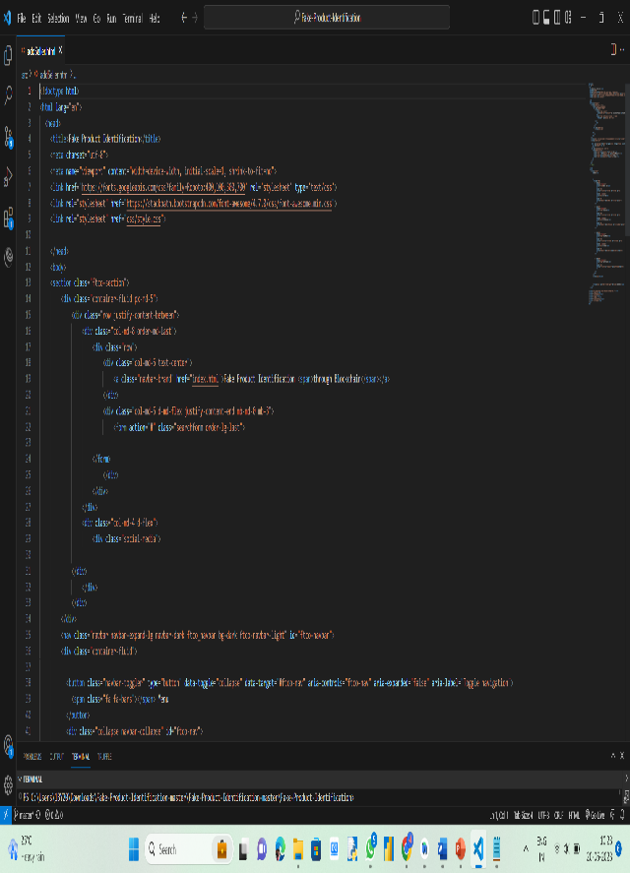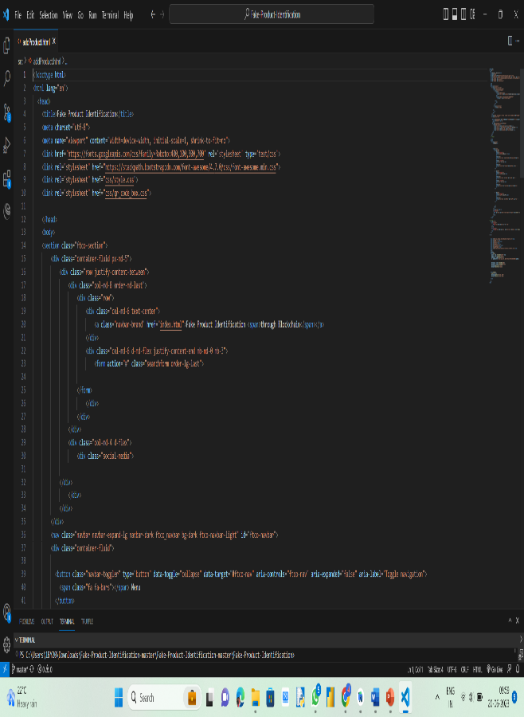 Seller.html Consumer.html

AddProduct.html AddSeller.html

**validation/result:**

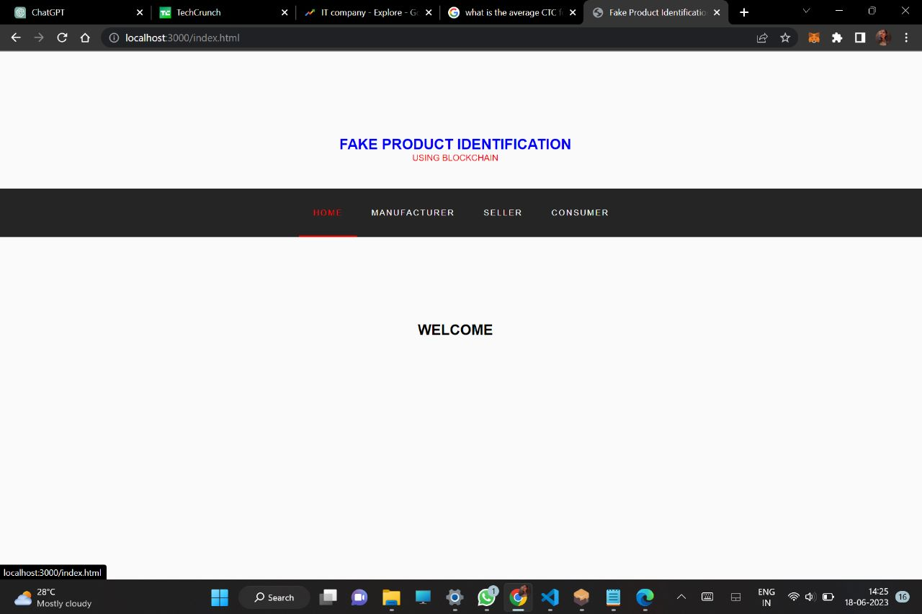

**FUTURE SCOPE AND ENHANCEMENT**

* The future work of the system can be proof of code simplicity which can indirectly increase consumer’s trust because of distributed applications.
* It can be difficult on the manufacturer side to add all the details of the products manufactured so instead of manually adding the products details, data can be extracted using company’s API which can increase efficiency and manufacturer friendly.
* QR code is not hackable but information in it can be copied or known to generate similarly QR code as well as print out of QR codeworks well to scan and retrieve information so in order to overcome this secure graphic QR code can be used that if when QR code is photocopied then it will lose information due to the ink smearing

**References:**

1. Muhammad Nasir Mumtaz Bhutta, Amir A. Khwaja, Adnan Nadeem, Hafiz Farooq Ahmad , Muhammad Khurram Khan, Moataz A. Hanif, Houbing Song, Majed Alshamari , and Yue Cao , “A Survey on Blockchain Technology: Evolution, Architecture and Security”, IEEE special section on intelligent big data analytics for internet of things, services and people,2021, pp. 61048 – 61073.
2. Rishabh Sushil Bhatnagar, Sneha Manoj Jha , Shrey Surendra Singh, Rajkumar Shende “Product Traceability using Blockchain”, 2020 2nd International Conference on Advances in Computing, Communication Control and Networking (ICACCCN).
3. Online:<https://www.geeksforgeeks.org/blockchain-technology-introduction/>